AAC v MP3
Name:
University:

AAC v MP3
While there are numerous codecs, the two most commonly used codecs are MP3 and AAC. MP3, Moving Picture Experts Group Layer-3 audio, is the most commonly used codec currently. The codec is compatible with many electronic gadgets. This file format has the ability to compact audio files drastically using lossy compression. By compressing files, this format saves on the utilization of space. Based on the audio encoding settings, an MP3 file can take as little as only 10% of the space occupied by a CD-quality audio file. The quality of MP3 files is determined by their bit rates. Files with higher bit rates have more data in them and sound better. Most MP3 files come in bit rates of 128, 192, and 256 kilobytes per second (kbps). Bit rates for MP3 files can either be variable or constant. Variable bit rates confer the advantage of utilizing smaller space hence their popularity. AAC, Advanced Audio Coding, also utilizes lossy compression (Waung, 2019). The format is also compatible with a wide variety of playback devices but is most often utilized for online streaming. It is also possible to compress files in this format. AAC is an improvement of MP3. Similar to MP3, the common bit rates for AAC files are 128, 192, and 256 kbps. However, both MP3 and AAC files can come in bit rates ranging from 8 to 320 kbps.
Both MP3 and AAC codec files are compressed by the removal of aspects of the audio files that do not impact on the listening experience. These parts majorly comprise the parts of the files with the fastest and lowest bit rates. Owing to the removal of these parts, MP3 and AAC files often lack some features of the original files hence the dub – lossy compression.
AAC codecs offer high quality of sound at a similar disc space to MP3. The superiority of AAC files is evident. In fact, AAC files at a bit rate of 256 kbps have a quality that surpasses that of MP3 files at any bit rate. First, unlike MP3 files, it is almost impossible for even experts to perceive differences between uncompressed and compressed AAC files. While in normal listening, it is difficult to differentiate between compressed and uncompressed MP3 files of any bit rate as well, subtle differences do exist. A discerning ear could elicit this decrease in the quality of files as a result of compression. Experts are almost certain to discern this difference. For AAC files, even experts would struggle to determine whether the files are compressed or not. This difference in the quality between AAC and MP3 files persists despite changes in file bit rate or in the genre of the files. With regards to genre, many experts regard music genres as either acoustic or electronic depending on the sound quality.
Waung (2019) provides a comparison of MP3 and AAC files with regards to the audio quality. The comparison was compiled after extensive expert research and is summarized in the attached screenshot as follows:
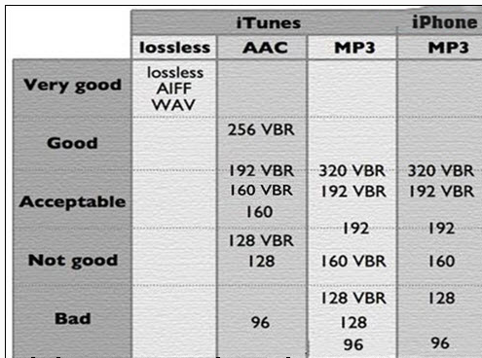
The comparison above is primarily based on a comparison of files of a similar genre. All the files utilized in compiling the comparison were of a variable bit rate (VBR).
The comparison demonstrates that the MP3 audio files only rarely achieve good and exceptional audio qualities. While AAC files at bit rates of 256 kbps have an exceptional quality, MP3 files with similar bit rates can only achieve achievable quality. MP3 files with even more data – up to 320 kbps – still only achieve acceptable but not exceptional quality. At a bit rate of 192 kbps, AAC VBR files have acceptable quality, however, at the same bit rate, MP3 VBR files have a quality that is borderline between acceptable and dismal (Waung, 2019). The picture does not change for lower bit rates. While AAC VBR files with bit rates of 128 kbps may provide an auditory experience that is not exceptional, the experience cannot be described as bad either. However, for MP3 VBR files, a bit rate of 128 kbps produces dismal audio quality.
The genre of the audio files is also a key determiner of the listening experience. Pras et al. (2009) demonstrated a significant difference in the preference of various musical clips of different genres with similar bit rates mainly in MP3. The other classified pop and other rapid clips as electric clips and slower clips like opera and orchestra as acoustic clips. Generally, listeners preferred electric clips. However, for expert listeners, the difference was negligible. The basis for the difference in this evaluation is the fact that that the sound produced by electric clips makes it easier for listeners to get the subtle differences between clips and to tell quality issues unlike the case for acoustic clips. Utilizing AAC clips would yield similar results. However, considering the superior quality of AAC clips, demonstrating the differences would be much more difficult. As such, the difference in the listening experience for clips of different genres would be less significant.
AAC codec is an improvement of the MP3 codec. Audio clips of the AAC codec are of higher quality compared to those of the MP3 codec. At similar bit rates, AAC sound clips have better quality and provide a better listening experience. Likewise, unlike MP3, the genre differences in the listening experience at similar bit rates are less pronounced.

References
Pras, A., Zimmerman, R., Levitin, D., & Guastavino, C. (2009, October). Subjective evaluation of mp3 compression for different musical genres. In Audio Engineering Society Convention 127. Audio Engineering Society.
Waung, S. (2019). AAC vs. MP3 - Which Music Format Sounds Better?. Retrieved from https://www.winxdvd.com/resource/aac-vs-mp3.htm

